**Stay Focused on**

**Mission 2022**

If you want to showcase your excellent work professionally, then Hassan can be the right choice. I am a professional web developer. A web template should contain some fundamental elements to express an individual’s expertise decently. I can meet those criteria perfectly.

Explore Now

Scroll down to explore more about me

**My Mission in 2022**

|  |  |  |
| --- | --- | --- |
| **Mission** | **Vision** | **Goals** |
| Being professional web developer,  To empower my clients to use the web to its full potential by providing affordable, effective, custom solutions. | I believe every day is an opportunity to further perfect our strategy and spur you on to achieve your organizational goals. My vision is to make you succeed in yours. | As a Web developer, I want to be able to design Web pages that can effectively display material, provide interactivity, and be artistically pleasing to the user. |

**Develop**

**Without Limits**

We have seen many portfolios, most of them are outstanding by design but not by purpose. if you want to get design works or clients you need to focus on showcasing your works. The big question is how are you showcasing your work? Then..

Read the Documentation

**Know our**

**Global Community**

As you can see here, I have a complete collection high-quality portfolio [website templates](https://cssauthor.com/single-page-website-templates-psd/) PSD designs. These templates are from profession designers around the globe. I have Selected only the best portfolio design templates to make your search easier.

Read the Documentation

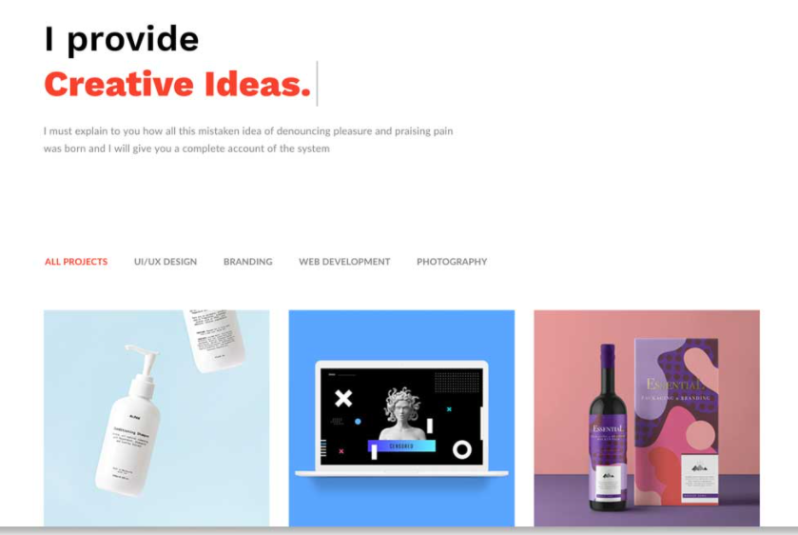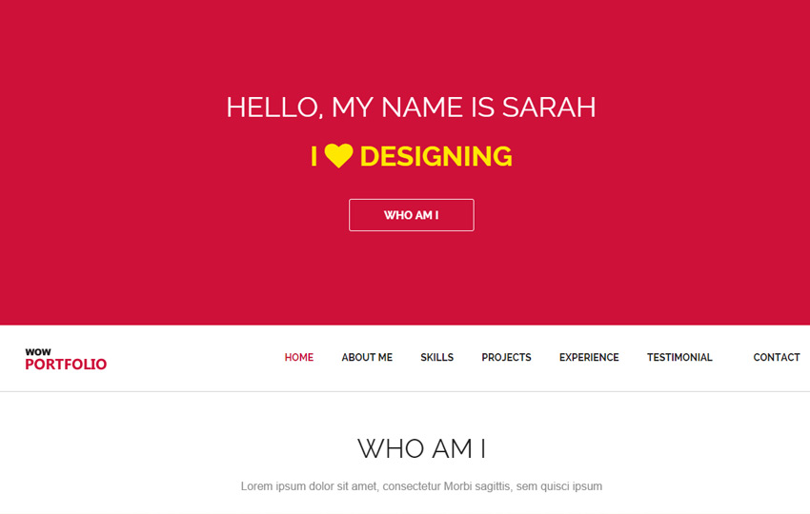

Mission 2022

Hard work, Perseverance, and Determination for 2022